FB-EK HOLDEN CAR CLUB OF SOUTH AUSTRALIA INC.
MERCHANDISE ORDER FORM

Please complete and forward to fbekholdencarclubofsa@gmail.com

Name: ______________________________________________________________________________

Address: ______________________________________________________________________________

Suburb: _________________________________________ Postcode: ___________________________

Home Phone: _______________________________ Mobile: __________________________________

Email Address: ________________________________________________________________________

**Below costs include club logo embroidered on front left of garment.
If you wish to have logo larger on the back, there will be additional costs of approx. $18-$22**

ITEMS AVAILABLE (please put in amount required)

Light weight Polo Shirt $30  Mini-waffle knit 160gm polyester moisture removal jkt | Button-up Shirt $40  65 % polyester & 35% cotton
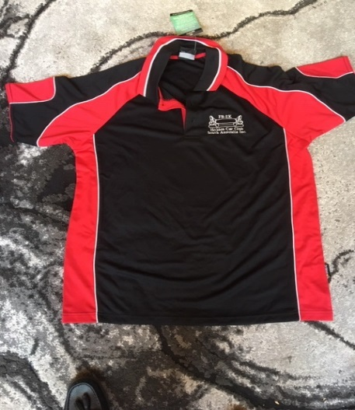 | 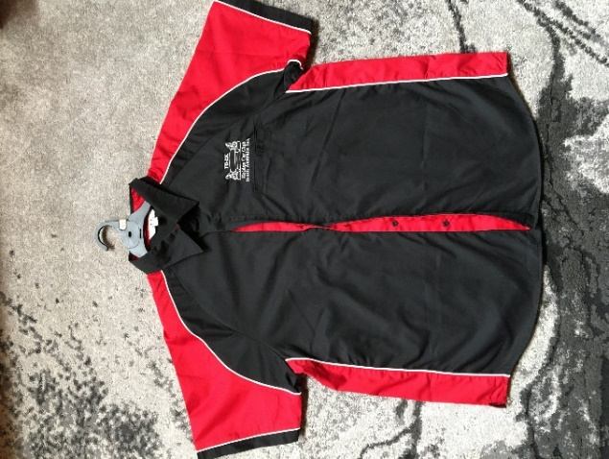
Mens - S, M, L, XL, 2XL, 3XL +5XL  Ladies - 8-26  Amount: _________ | Mens - S, M, L, XL, 2XL, 3XL +5XL  Ladies - 8-26  Amount: _________
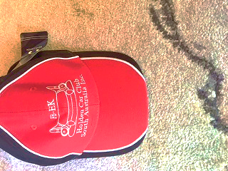 | 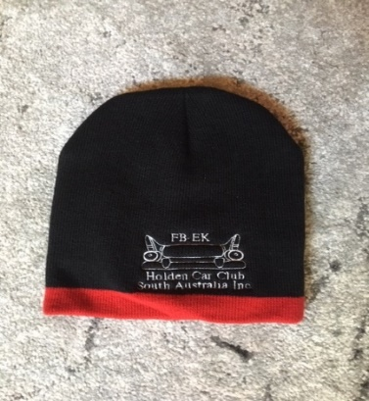
Cap $15  Amount: _________ | Beanie $15  Amount: _________
Hoodie $45  Panorama with full zip.  Light weigh 300gms cotton % polyester fleece | Light weight Jacket $100 Nitro  PU Coated Jacket with micro fleece lining
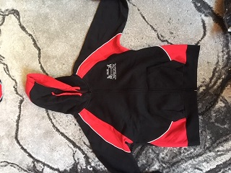 | 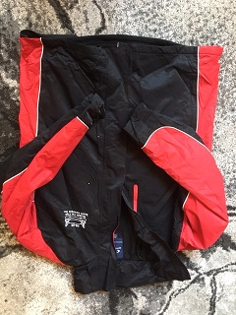
Mens - S, M, L, XL, 2XL, 3XL +5XL  Ladies - 6-16  Amount: ________ | Size - Small to 5XL  Amount: _________

POST OR COLLECT + $15.00 (Postage) TOTAL _______________________

Bank account details:
FB-EK Holden Car Club of SA Inc.
Westpac
BSB 035-202
Account No. 159-538
**Please use surname as a reference**

OFFICE USE ONLY
Receipt No: _____________ Date: __________________ Signature: ______________________________
Payment Details: CASH / MONEY ORDER / CHEQUE / DIRECT DEPOSIT

